**Customize a SharePoint list form by using Power Apps**

You can easily customize the form for a SharePoint list by opening Power Apps in a browser. You don't need to write traditional code, such as C#, or download another app, such as InfoPath. When you publish your changes, the form is embedded within the SharePoint list for use by all of its users. In Power Apps, you can also review analytics reports, easily create conditional formatting, and connect to other data sources.

## **Create a list**

On a SharePoint site, create a list, and then add these columns to that list:

* **Details** (yes/no)
* **Price** (currency)
* **Availability** (date without time)
* **Color** (choice)



## **Open the form**

1. In the command bar, select **PowerApps**, and then select **Customize form**.

Power Apps Studio opens in the same browser tab.

1. If the **Welcome to Power Apps Studio** dialog box opens, select **Skip**.



## **Move and remove a field**

1. Drag the **Availability** field to the bottom of the list of fields.

The fields appear in the order that you specify.

1. Hover over the **Attachments** field select the ellipsis (...) that appears, and then select **Remove**.

The field that you specify disappears from the form.



## **Set conditional formatting**

You can configure the **Price**, **Availability**, and **Colors** fields to appear only if **Details** is set to yes.

1. In the left navigation bar, expand **Details_DataCard1**, and note the numeral that appears at the end of **DataCardValue**.
2. Set the **Visible** property of the **Color**, **Availability**, and **Price** cards to this formula (replacing, if necessary, the numeral with the one that you noted in the previous step):

**If(DataCardValue2.Value = true, true)**

1. While holding down the Alt key, select the **Details** toggle (by clicking or tapping it) multiple times.

The three fields that you configured appear and disappear from the form.



## **Save and publish the form**

1. Open the **File** menu, select **Save**, and then select **Publish to SharePoint** twice.
2. In the upper-left corner, select the back arrow, and then select **Back to SharePoint**.



## **Further customize your form**

1. Open your list, select **New** in the command bar, and then select **Customize** near the top of the form.
2. Customize your form in a variety of ways, such as those that these topics describe:
   * Change its size, orientation, or both (for example, to [make the form wider](https://docs.microsoft.com/en-us/powerapps/maker/canvas-apps/set-aspect-ratio-portrait-landscape)).
   * [Customize one or more cards](https://docs.microsoft.com/en-us/powerapps/maker/canvas-apps/working-with-cards) (for example, change a card's display text or input control).
   * Create a [lookup field](https://docs.microsoft.com/en-us/powerapps/maker/canvas-apps/sharepoint-lookup-fields).

## **Use the default form**

1. From your list in SharePoint, open the settings page (by selecting the gear icon near the upper-right corner), and then select **List settings**.
2. Under **General settings**, select **Form settings**.
3. On the **Form Settings** page, select one of these options, and then select **OK**.
   * **Use the default SharePoint form** - When a user opens your list and selects **New** in the command bar, the default form for the list will appear.
   * **Use a custom form created in Power Apps** - When a user opens your list and selects **New** in the command bar, your custom form will appear. (As an alternative, you can publish the form again in Power Apps.)

You can toggle back and forth between options, as needed.

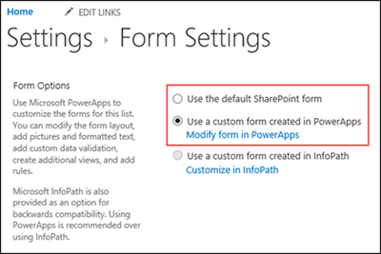

## **Delete the custom form**

1. From your list in SharePoint, open the settings page (by selecting the gear icon near the upper-right corner), and then select **List settings**.
2. Under **General settings**, select **Form settings**.
3. On the **Form Settings** page, select **Use the default SharePoint form**, and then select **Delete custom form**.

